Computer Language Diagrams

Method Call in a Diagram
The principle of a method call is explained in the article Method Call. This article demonstrates its expression in a diagram.

A method call in a diagram is represented by a diamond shape.



This as opposed to a method definition, which is represented by a square.



It needs to be specified which method is called. This is done by connecting the diamond, representing the call, with the square, representing the definition.

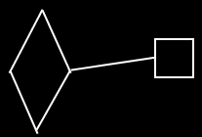

See also: Method Call, Method in a Diagram

Author & Copyright: Jan-Joost van Zon Date: May 24, 2008 – May 24, 2008 Location: Oosterhout, The Netherlands Status: Finished

